**Storage ::**

In Azure, the storage account is the unique Azure namespace for your data.

* Every object in Azure has its own web address

For example, if my storage account was named acloudguru

Name will be acloudguru.<storage-type>.core.windows.net

This also means that this unique name of your storage account must be globally unique across all of Azure.

**Blob –** Binary Large Object

* These blobs of data are stored in containers, inside the storage account.
* That means there are three layers to Blob storage: storage account, container, and then blob.

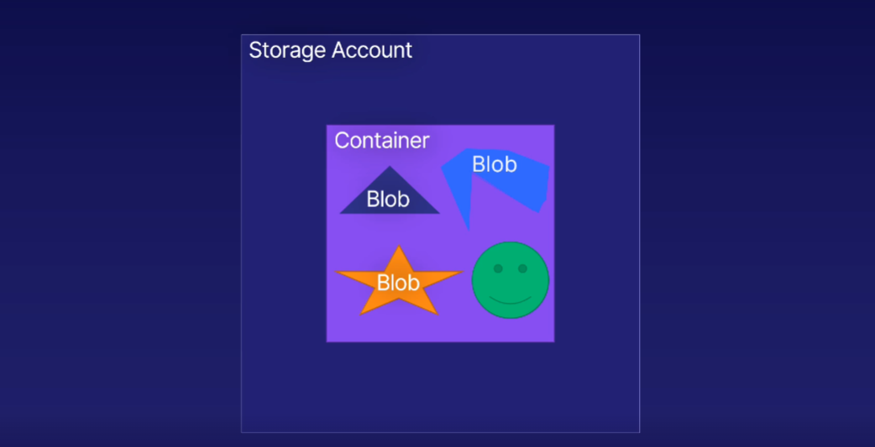

* In Blobs we can store any type of data and in any size.
* The blobs or items will have a unique address. So we can able to get data easily.
* We can store any type of data such as images, audio files, video files, log files, backup and disaster recovery.

Azure storage supports 3 types of blobs::

1. block blobs
2. append blobs
3. page blobs

**Block Blobs**

* Block blobs are made up of blocks, each of which is identified by a block ID.
* Each block can be a different size, up to the maximum size permitted for the service version in use.
* A block blob can include up to 50,000 blocks.
* Block blobs can store text and binary data, up to approximately 4.75 TiB.
* Block blobs are ideal for storing text or binary files, and for uploading large files efficiently.
* When you store an audio file in an Azure Block Blob (or any blob storage system), it is treated as binary data.

**Append Blobs**

* Append blobs are a type of blob that are optimized for appending data to existing datasets.
* They are made up of blocks. Append blobs can contain up to 50,000 blocks.
* Append blobs are designed for efficient write operations.
* When you modify an append blob, blocks are added to the end of the blob only. Updating or deleting of existing blocks is not supported.
* They are ideal for scenarios such as logging data from virtual machines.

**Page Blobs**

* Page blobs are a type of Azure Blob storage that are used to store large, random-access files.
* They are optimized for random read-write operations
* They are particularly suited for scenarios where you need to read and write small sections of a file without affecting the entire file.
* Any part of the file can be accessed any time.
* Page blobs are used primarily as the backing storage for the VHDs (Virtual Hard Disk) used to provide durable disks for Azure Virtual Machines (Azure VMs).

**Pricing Tiers for blobs::**

HOT COOL ARCHIVE

Access time is less More More compare to hot and cool

Storage cost is High Low Low

Access cost is Low High High

Hot is used for data that is frequently accessed

Cool is used for data that is infrequently accessed.

Archive is used for data that you need to store for a very long time but expect to access very rarely.

**Disk**

* Disk storage is a Disk
* Disk storage is referred to, is what you attach to your VMs.
* Azure will look after the physical disk for you and guarantees its uptime and backup. (Uptime refers to the amount of time that a computer system, server, application, or service is operational and available for use.)
* Azure guarantees Size and performance of the disks.
* Easy to upgrade your disk size and type.

Four types of Disks for VM::

1. HDD – Hard Disk Drive

This is a low cost storage option for having data that you can access infrequently. This is for scenarios like backup, or for testing any scenarios you're developing.

1. Standard SSD – Solid State Drive

This is generally standard for production environment, running a VM with a Standard SSD gives you lower latency than a HDD, improved reliability, and better scalability.

1. Premium SSD

* This is superfast, high performance storage for your critical workloads.
* Premium SSDs are recommended for database installations in particular, as the latency is very low.
* Premium SSD is better than Standard SSD.

1. Ultra Disk

* This is for your most demanding, data intensive workloads, delivering unprecedented and extremely scalable performance with sub-millisecond latency.
* You can even have disks up to 64 terabytes in size, huge.
* Microsoft recommends this tier for transaction heavy workloads, complex analytical modeling, gaming, rendering, and low queue depth databases.
* So, that's disk storage, a flexible, managed solution for your VM and other services.

**File**

On-Premises File storage Problems:

* You only have a limited amount of storage
* More time and resources need to spent on maintaining backups
* It is hard to keep all data secure at all times. Specialist assistance is needed.
* It is Difficult to share files across teams and organizations.

All the above problems will be solved by using File Storage Account in cloud

* By using cloud file storage we can share access to your on-premises infrastructure.
* You don’t have to worry about hardware or OS
* Network and power outages won’t affect your storage.

**Archive::**

Data archiving is the process of moving data that is no longer actively used to a separate storage device for long-term retention.

Financial Records, Emails, Legal Documents, Healthcare records, Historical records, Research data, Business data, Backup data

We can use archive that is present in cloud…….

* The archive tier is the lowest price for storage on azure
* Archive in cloud is durable, encrypted and stable. So it is perfectly suited for data that is accessed infrequently.
* By using cheap archive account in cloud you can save your more premium on-premises storage.
* It is fully secured to allow for any personal data such as financial records, medical …….
* Archive storage is blob storage, so the tools will work on blob is used on archive also.

Storage Redundancy::

When it comes to storing critical data, you need to know that your data is protected against unexpected failures.

* It creates multiple replicated copies of your data.
* Copying data is completely automatic
* Minimum 3 copies will be created.
* This copying process is invisible to end user.
* Higher availability means higher cost.

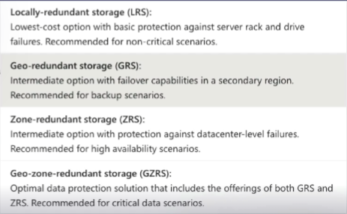

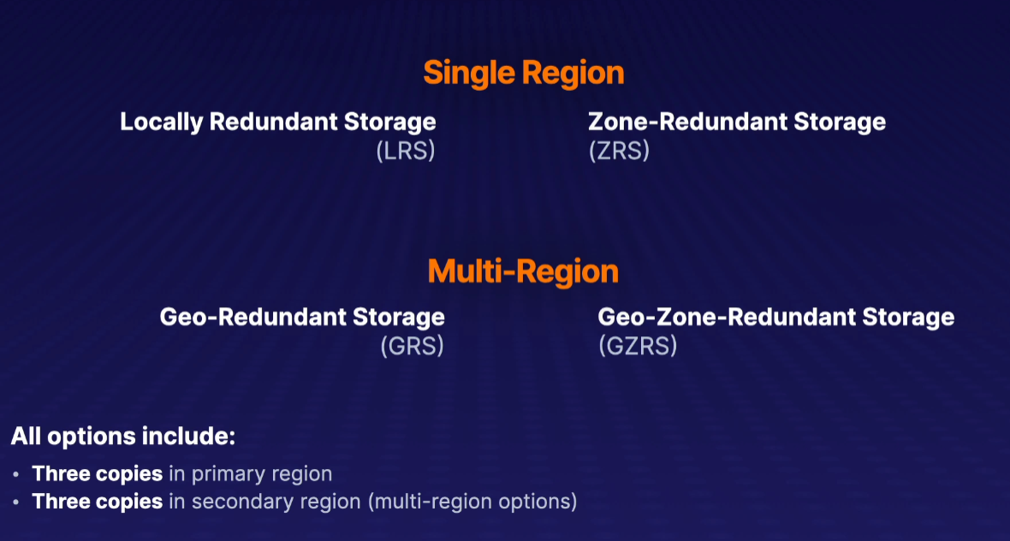

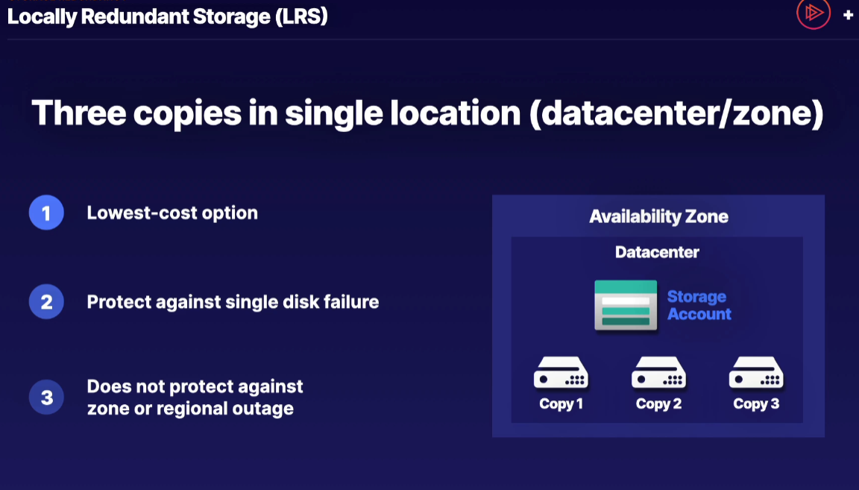

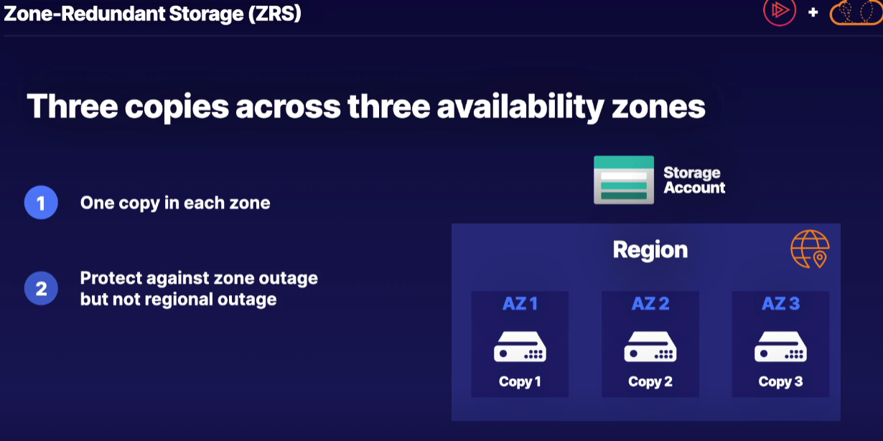

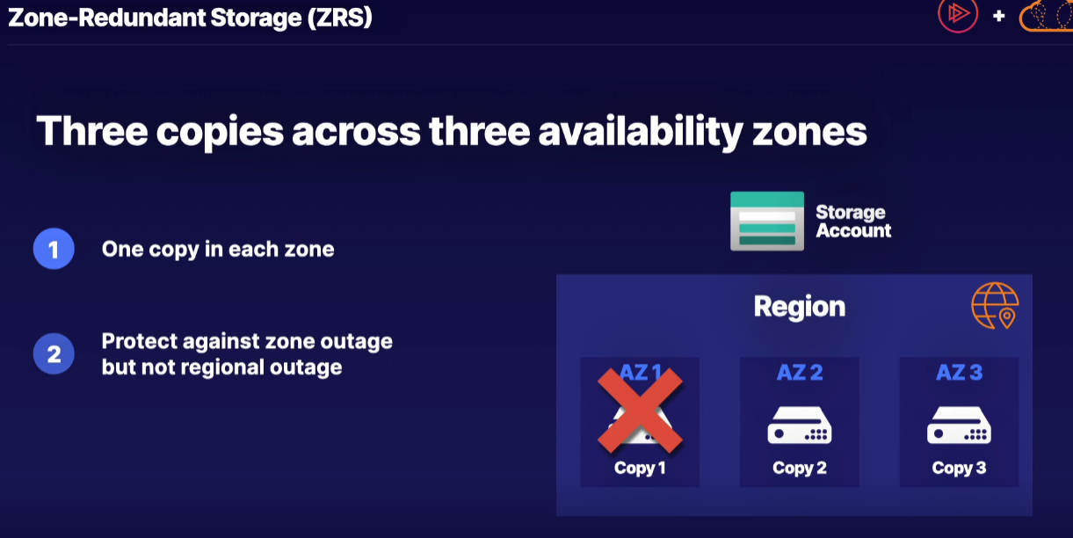

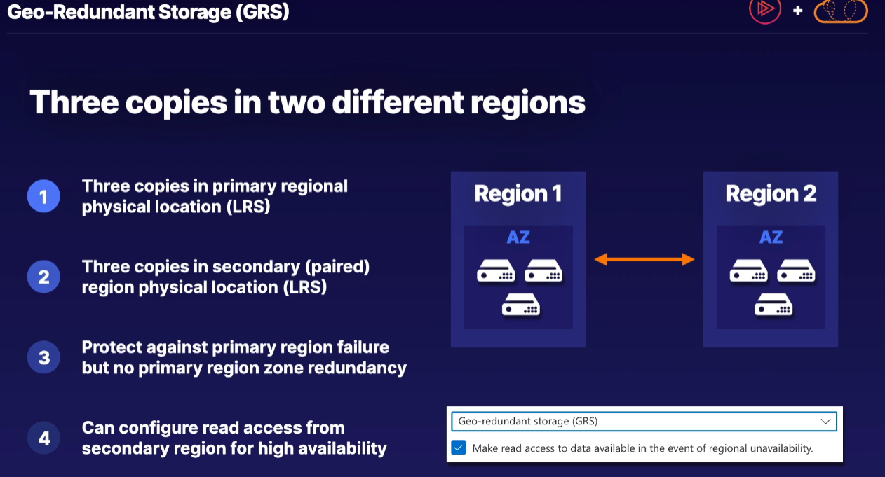

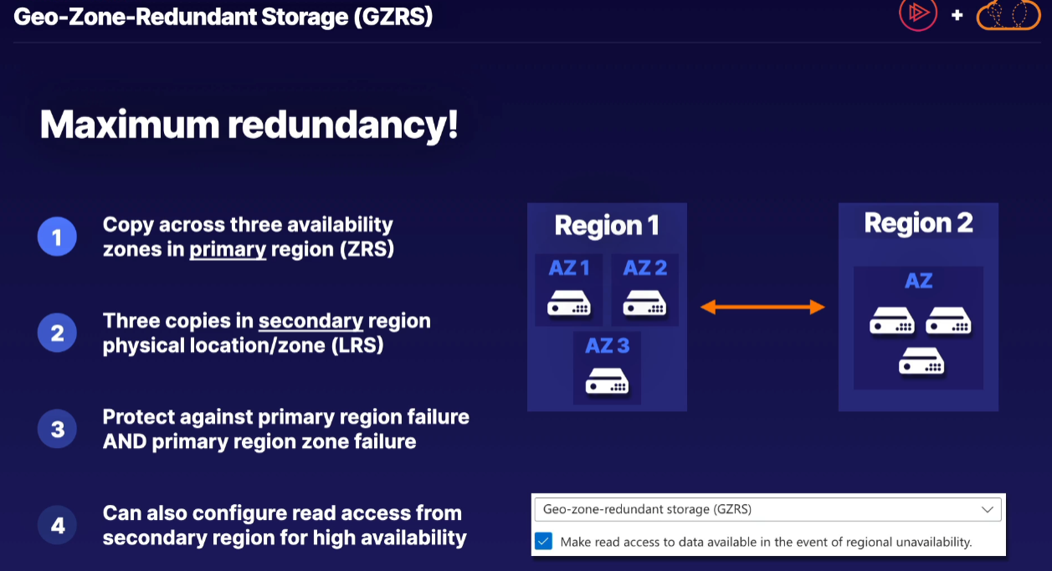

Moving Data::

(Occasional Transfer)

Azure provides a number of solutions depending on specific use cases. when you're moving data into an out of Azure Storage, whether it is from an on-premises location, or maybe even another cloud provider, there are different solutions available

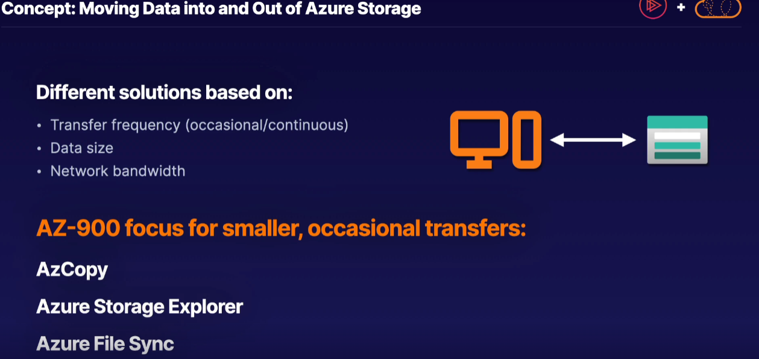

AzCopy::

* AzCopy is a command-line utility for occasional data transfers.
* It is a downloaded application.
* It is able to transfer both blob and Azure Files storage types.
* It is especially useful for automated scripting routines
* Integrated in both Bash and PowerShell scripts for different automated routines.

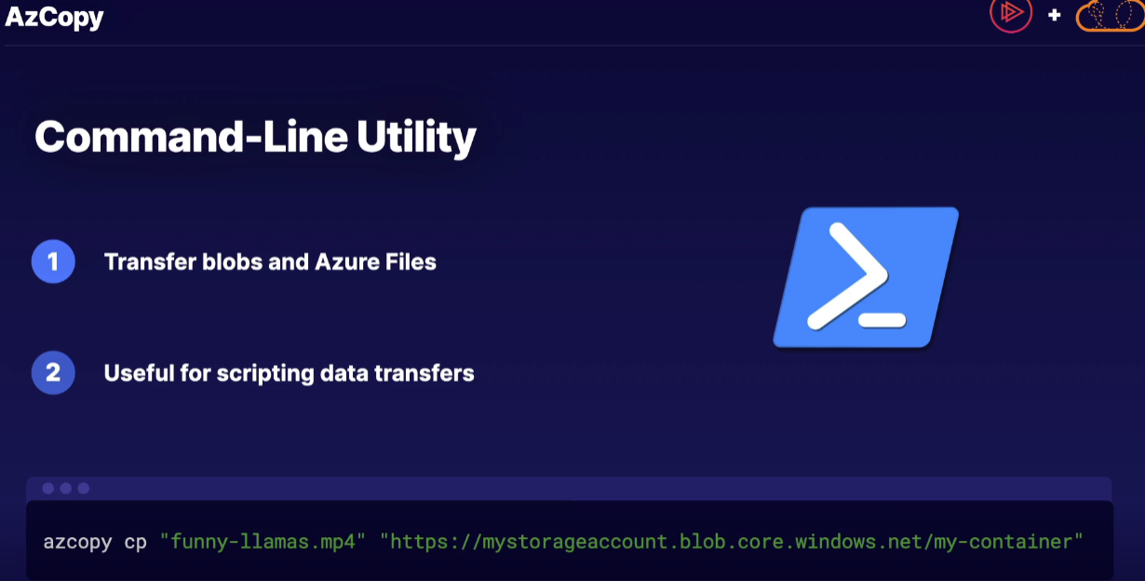

Storage Explorer::

* Storage Explorer is a graphical user interface, or a GUI interaction method
* Using Storage explorer we can simply drag and drop different data types into and out of Azure Storage.
* We can move all types of storage accounts ( not only blob and files storage)

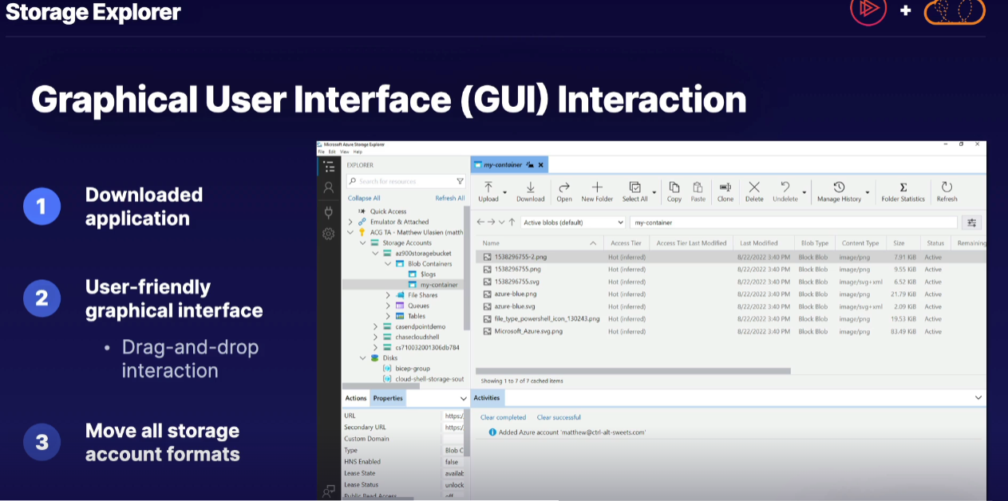

Azure File Sync::

* This works specifically with Azure Files storage format in which it will automatically synchronize the Azure File Service with on-premises file servers.
* We can use this situations like you have on-premises locations with local file servers however you want to maintain the cloud availability
* We can synchronize files between multiple on-premises locations.

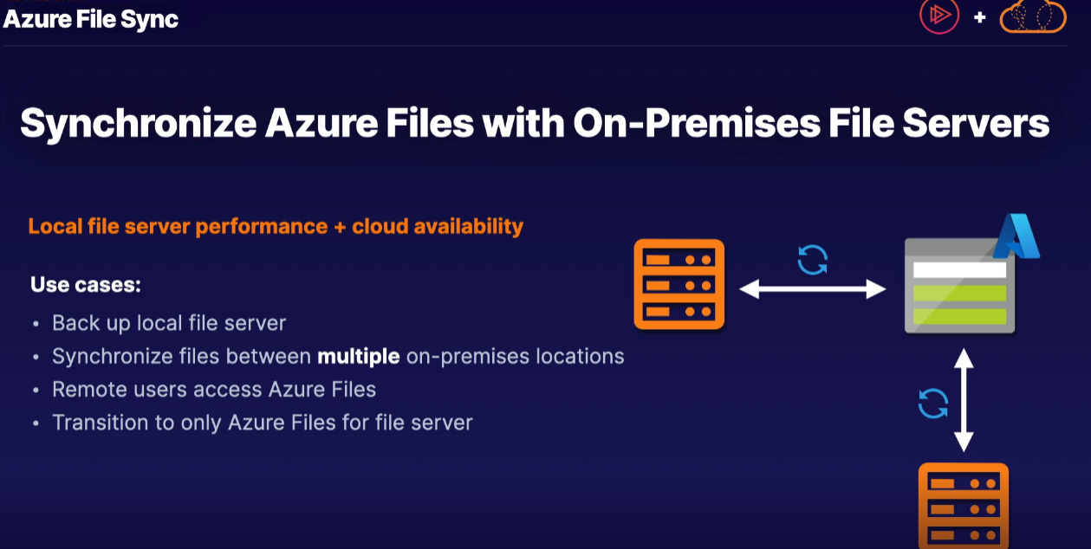

(Continuous/ heavy Transfer)

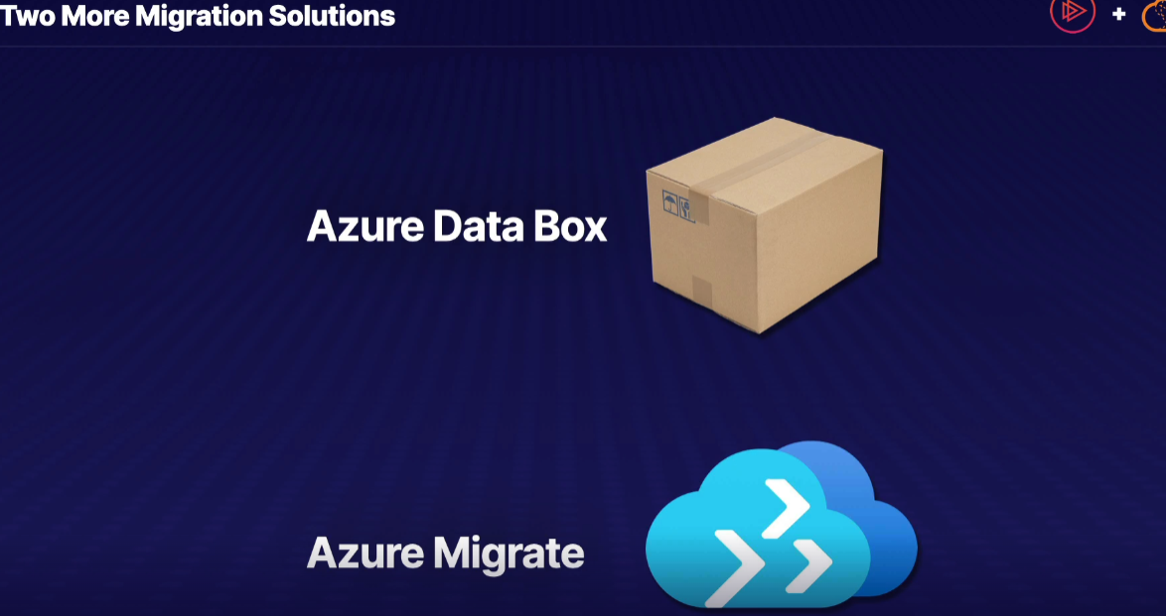

Azure Data Box::

This is used in the scenario of transfer lots (Too much to transfer over the internet) of data and/ or limited network bandwidth.

* Offline data transfer to/from Azure
* Order and receive the Data Box, prepare and copy data.
* Copy data to physical data storage device (Data box)
* Configure, seal, and schedule pickup, and Microsoft handles secure data transfer to Azure, after which you access and manage data in the cloud.
* To Azure : Data box data is transferred to storage account
* From Azure : Data box delivered to on-premises location for on-site transfer

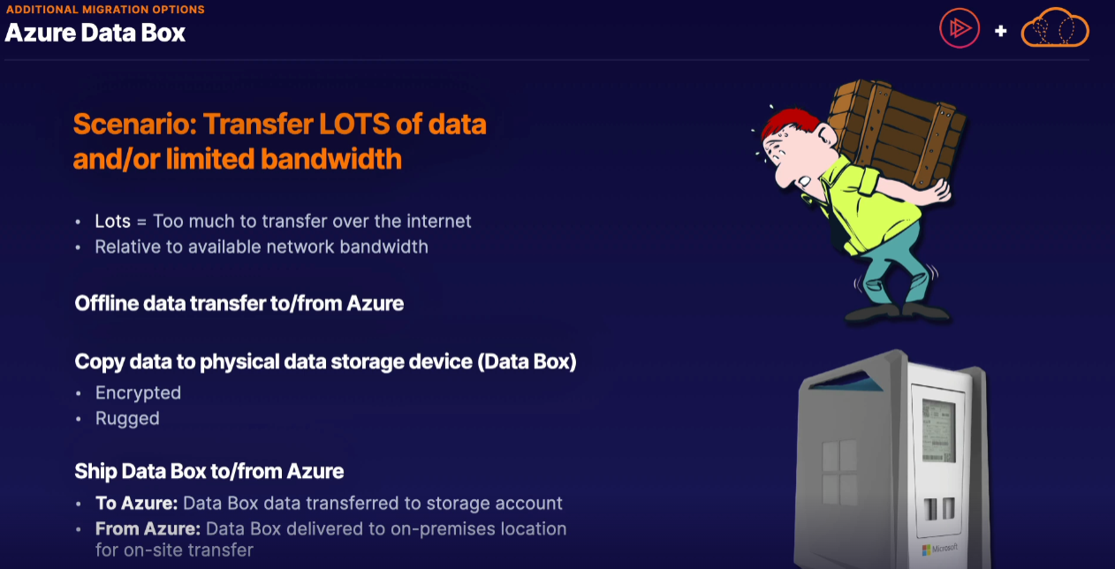

! Order the device and receive it.

! Prepare data, configure the device, and copy data onto it.

! Seal the device and schedule a pickup.

! Microsoft securely transfers the data to Azure.

! You access and manage your data in Azure once it's imported.

Azure Data Box used Scenarios::

1. Initial bulk data migration
2. Disaster recovery

We have an on-premises disaster that we need to restore from backed up data in our Azure Storage location. In the event it is a large amount of data that we simply cannot quickly transfer over the internet, we can simply restore an Azure-side backup to an Azure Data Box, have it then shipped to our on-premises location for a restore process.

1. Security Requirements

We have data that is deemed too sensitive to transfer over the network, in which case, we need to perform an offline data transfer for security requirements instead.

Azure Migrate::

Azure Migrate is a tool provided by Microsoft to help organizations move their computer systems and data from their own data centers (on-premises) to Microsoft's cloud platform, Azure. Here's a simplified step-by-step process:

1. Prepare: Set up an Azure account and create a project for your migration.
2. Discover: Install a tool on your on-premises servers to collect information about them.
3. Assess: Based on the collected data, Azure Migrate helps you understand which servers can be moved to Azure, what kind of virtual machines you need in Azure, and how much it might cost.
4. Plan: Create a plan for how you'll move your servers. This includes deciding which servers to move first and setting up the necessary resources in Azure.
5. Migrate: Actually move your servers to Azure according to your plan. This might involve copying data and configurations from your own servers to Azure.
6. Test and Verify: After moving, you should test your systems in Azure to make sure they work correctly.
7. Optimize: Monitor your systems in Azure and make adjustments to save money or improve performance.
8. Repeat: You can use Azure Migrate for multiple servers or applications, so you can repeat this process as needed.

The goal is to make it easier for organizations to take advantage of the benefits of cloud computing without having to completely rebuild their computer systems. Azure Migrate provides tools and guidance to make this process as smooth as possible.

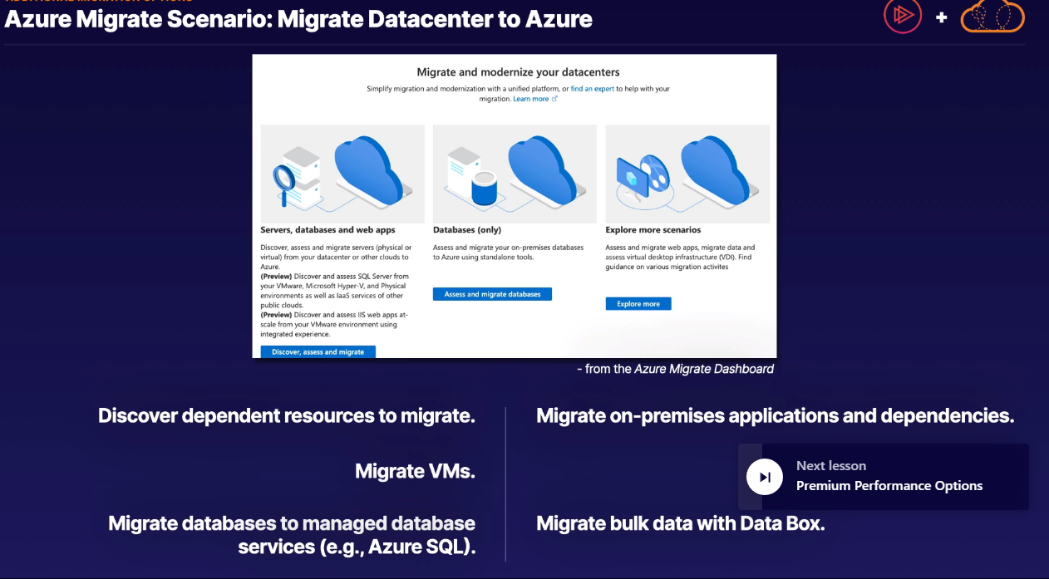

Premium Performance options::

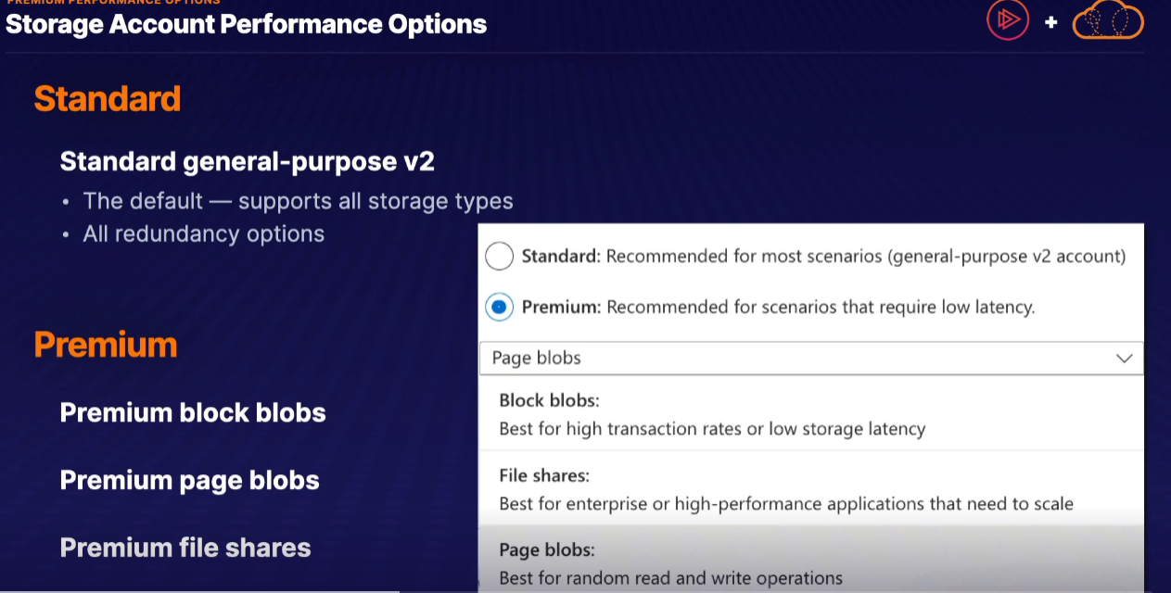

Standard ::

* Supports all storage types
* Supports all redundancy options

Premium ::

